1. Map Chart
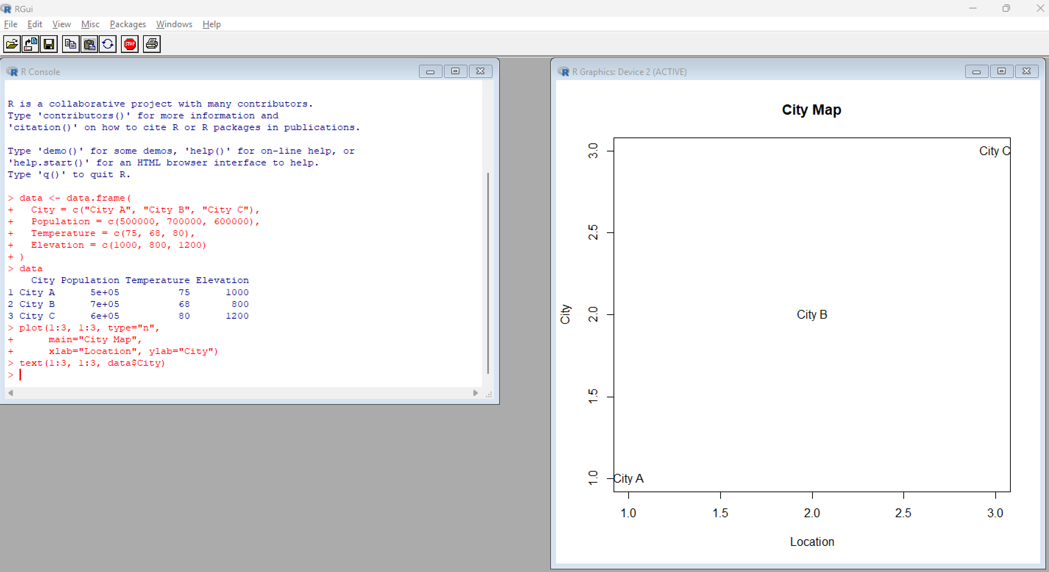
2. Scatter Plot – Temperature vs Population
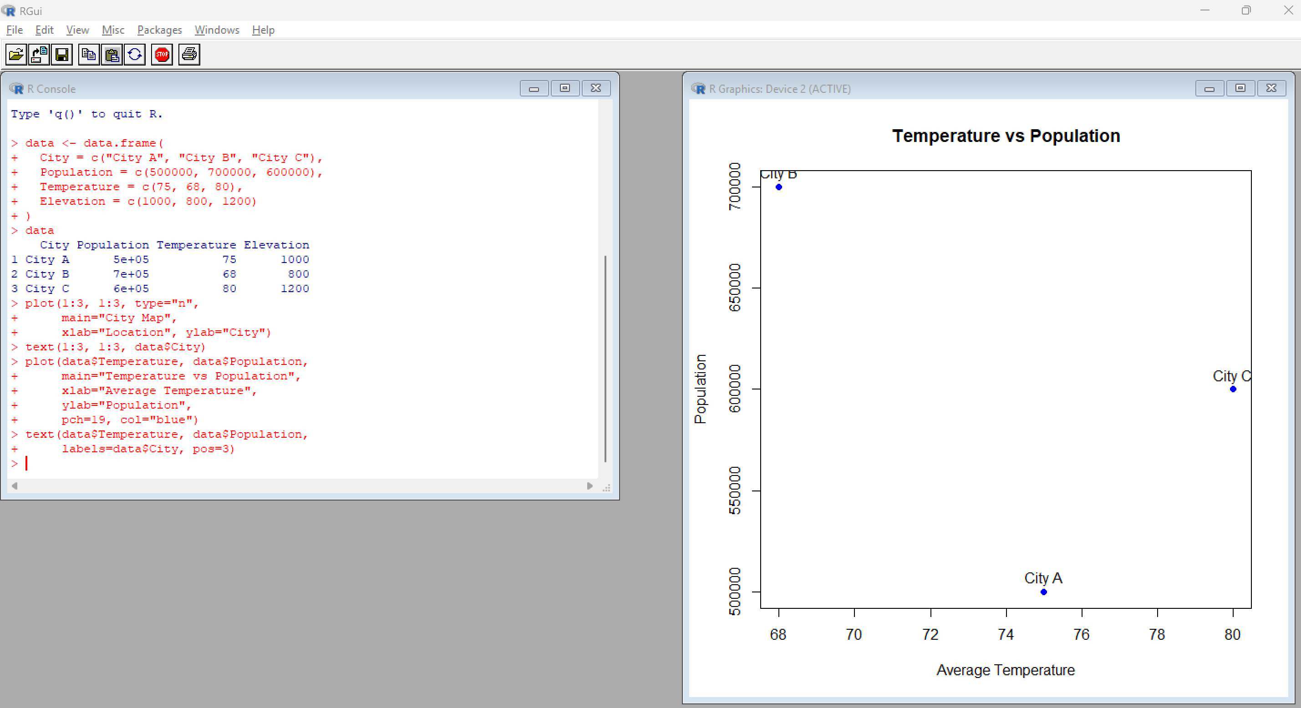

3. Table – Geographic Data
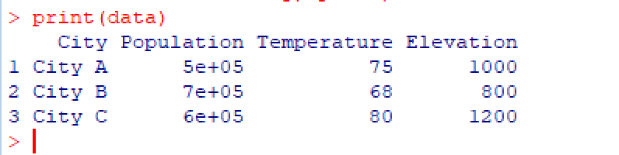

4. Tableau Dashboard
